IPC 6012 PWB COMPLIANCY FOR EVLA BASELINE
BOARD

CUSTOMER: National Research Council/DRAO
PROJECT NAME: IPC 6012 PWB Compliancy - EVLA Baseline Board
PROJECT NUMBER: Z34-006223-55

This document has been approved by the following functions responsible for its implementation:
Name | Title | Signature | Date

Revision History
Version | Date | Author (s) | Description of Change
01 | April 27, 2009 | L. Zhu/L. Cutler | Initial Release

CONFIDENTIAL INFORMATION
This is a confidential document that contains proprietary information and trade secrets of BreconRidge Corporation. No part of this document may be used, transmitted, reproduced or disclosed in any form or by any means without the prior written permission of BreconRidge Corporation.
Copyright © 2009 BreconRidge Corporation. All rights reserved.
TABLE OF CONTENTS
1 overview 5
1.1 Purpose 5
1.2 Reference documents 5
definitIOn of terms 5
1.3 5
2 Merix IPC 6012 compliance 6
3 Bow and Twist Measurement, Pre and Post SMT ASSEMBLY 10
3.1 MEthod 10
3.2 Test SETUP 11
3.3 Results 12
3.4 Discussion 16
4 IST TESTING 17
4.1 IST TESTING APPROACH 17
4.2 IST test condition 22
4.3 IST test Results 22
4.4 IST test Coupon cross section 28
5 conclusion and Qualification Status 32

TABLE OF TABLES
Table 1: Reference Documents 5
Table 2: Acronyms 5
Table 3: Merix Acceptance Testing and Frequency 6
Table 4 Test Equipment Detail 11
Table 5: Bow and Twist Testing Results 12
Table 6: IST Test Coupon Design 17
Table 7: Resistance Pre-screen Data for 0.028” DHS 18
Table 8:Resistance Prescreen Data for 0.0118” DHS 19
Table 9: Resistance Prescreen Data for 0.0098” DHS Blind Via for Layers 1-14 20
Table 10: Resistance Prescreen Data for 0.0098” DHS Blind Via for Layers 15-28 21
Table 11: IST Assembly Pre-conditioning 22
Table 12: IST Test Conditions 22
Table 13: IST Results for 0.028” DHS 23
Table 14: IST Results for 0.0118” DHS 23
Table 15: IST Results for 0.0098” DHS Blind Via for Layers 1-14 24
Table 16: IST Results for 0.0118” DHS Blind Via for Layers 15-28 24

TABLE OF FIGURES
Figure 1: Setup on CMM for twist measurement. Only 3 corners are constrained to the reference plane formed by the posts mounted to the press fit plate 11
Figure 2: Orientation for the Warp and Twist Measurement 12
Figure 3: Bow of Board 1 Pre and After Assembly, dimensions in mm. 13
Figure 4: Bow of Board 2 Pre and Post Assembly, dimensions in mm 14
Figure 5: Bow of Board 3 Pre and Post Assembly, dimensions in mm 15
Figure 6: Component PTH Assembly Conditioning: Ambient to 230°C for 6 IST cycles 25
Figure 7: Via PTH Assembly Conditioning: Ambient to 230°C for 6 IST cycles 26
Figure 8: Blind Via Layers 1-14 Assembly Conditioning: Ambient to 230°C for 6 IST cycles Drill Hole Size 0.0098” 27
Figure 9: Blind Via Layers 15-28 Assembly Conditioning: Ambient to 230°C for 6 IST cycles Drill Hole Size: 0.0098” 28
Figure 10 (A) PTH image of an untested coupon (B) PTH image of a tested coupon, 500 thermal cycles 29
Figure 11 (A) Via PTH image of an untested coupon (B) Via PTH image of a tested coupon, , 500 thermal cycles 30
Figure 12 (A) Blind via (1-14) image of an untested coupon (B) Blind via (1-14) image of a tested coupon, ,500 thermal cycles 31
Figure 13 (A) Blind via (15-28) image of an untested coupon (B) Blind via (15-28) image of a tested coupon, , 500 thermal cycles 31

overview

Purpose
This document outlines the reliability engineering services that were conducted by BreconRidge Corporation (BreconRidge) for National Research Council for ELVA Baseline Board to qualify Merix Corporation, a new PWB supplier for the product. The reliability work performed is in accordance with STATEMENT OF WORK # 2 - IPC 6012 PWB COMPLIANCY – EVLA BASELINE BOARD.
This document summarises the testing results for the following information:
- Review of new PWB supplier’s compliance with IPC 6012 and test coverage
- Interconnect Stress Testing on one lot and review of data and cross sections
- Bow and twist of bare PWB board (3x parts), and as assembled CCA (3x parts)

Reference documents
Table 1: Reference Documents
Document number | Title
IPC-6012B | Qualification and Performance Specification for Rigid Printed Boards
IPC-TM-650 | Test Method Manual  2.4.22C Bow and Twist (Percentage)
IPC-TM-650 | Test Method Manual  2.6.26 DC Current Induce Thermal Cycling Test
SOW#2 | IPC 6012 PWB COMPLIANCY – EVLA BASELINE BOARD (November 24, 2008)
IPC-2221 | Generic Standard on Printed Board DesignI

definitIOn of terms
Table 2: Acronyms
Term | Definition
BreconRidge | BreconRidge Corporation
NRC/DRAO | National Research Council/Dominion Radio Astrophysical Observatory
Merix | Merix Corporation
PWB | Printed Wiring Board
CCA | Circuit Card Assembly
IST | Interconnect Stress Test
AM | Asset Management

Merix IPC 6012 compliance
Merix demonstrates PWB manufacturing compliance with IPC 6012. Table 3 is a summary outlining the acceptance criteria and frequency of the testing.
Table 3: Merix Acceptance Testing and Frequency
 | IPC 6012 section | Performed on product first run (FAI) | Performed per product batch work order | Performed on sample basis | Other | Notes
Inspection
Material | 3.2.1-3.2.14 | X | X
Visual
Edges of board | 3.3.1 | X | X
Laminate imperfections | 3.3.2 | X | X
Voids in plated hole | 3.3.3 | X | X
Lifted lands | 3.3.4 | X | X
Marking and traceability | 3.3.5 | X | X
Workmanship | 3.3.9 | X | X
Solderability
Surface/hole | 3.3.6 |  |  |  | X | Process Control
Dimensional
Board dimensional | 3.4 | X |  |  | X | Process control on production lot
Hole pattern accuracy | 3.4.1 | X | X
Pattern feature accuracy | 3.4.1 | X | X
Annular ring (external) | 3.4.2 | X | X
Bow and twist | 3.4.3 | X | X | X |  | Sample per lot
Solder resist coverage | 3.7-3.7.1 | X | X
Plating/coating thickness (electronic) | 3.6.2.11 | X | X | X |  | Sample per lot
Conductor Width
Internal | 3.5.1 | X | X
External | 3.5.1 | X | X
Conductor Spacing
Internal | 3.5.2 | X | X
External | 3.5.2 | X | X
Conductive Surfaces (Surface Only)
Edge board contact, junction of gold plate to solder finish | 3.3.8 | X | X
Nicks, dents, pinholes | 3.5.4.1 | X | X
Dewetting/nonwetting/final finish coverage | 3.5.4.5  3.5.4.6  3.5.4.7 | X | X
Edge board connector | 3.5.4.4 | X | X
Surface mount | 3.5.4.2 | X | X
Physical
Plating adhesion | 3.3.7 | X | X |  |  | Sample per lot
Solder resist cure and adhesion | 3.7  3.7.2 | X | X |  |  | Sample per lot
Structural Integrity After Stress Types 3-6 (Micro-section)
Plating integrity | 3.6.2.1 | X |  | X |  | If requested micro-section can be done per lot
Laminate voids | 3.6.2.3 | X |  |  |  | If requested micro-section can be done per lot
Etchback/negative etchback | 3.6 a & b  3.6.2.6  3.6.2.8 | X |  |  |  | If requested micro-section can be done per lot
Annular ring (internal) | 3.6 a & b  3.6.2.9 | X |  |  |  | If requested micro-section can be done per lot
Lifted lands | 3.6.2.10 | X |  |  |  | If requested micro-section can be done per lot
Hole plating thickness | 3.6 a & b  3.6.2.11 | X |  |  |  | If requested micro-section can be done per lot
Surface plating and conductor thickness | 3.6 a & b  3.6.2.11  3.6.2.13 | X |  |  |  | If requested micro-section can be done per lot
Conductor thickness (internal) | 3.6 a & b  3.6.2.12 | X |  |  |  | If requested micro-section can be done per lot
Metal core spacing | 3.6.2.14 | X |  |  |  | If requested micro-section can be done per lot
Dielectric thickness | 3.6 a & b  3.6.2.15 | X |  |  |  | If requested micro-section can be done per lot
Resin fill of blind/buried vias | 3.6.2.16 | X |  |  |  | If requested micro-section can be done per lot
Structural Integrity after Stress Types 2 (Micro-section)
Plating integrity | 3.6.2.1 | X |  |  |  | If requested micro-section can be done per lot
Laminate integrity | 3.6 a & b  3.6.2.3 | X |  |  |  | If requested micro-section can be done per lot
Lifted lands | 3.6.2.10 | X |  |  |  | If requested micro-section can be done per lot
Hole plating thickness | 3.6 a & b  3.6.2.11 | X |  |  |  | If requested micro-section can be done per lot
Surface plating and conductor thickness | 3.6 a & b  3.6.2.11  3.6.2.13 | X |  |  |  | If requested micro-section can be done per lot
Electrical
Circuit continuity | 3.8.2.1 | X | X
Insulation resistance | 3.8.2.2 | X | X
Cleanliness
Cleanliness prior to solder resist application | 3.9.1 |  |  |  | X | Process control
Special Requirements (when specified)
Metal core (horizontal micro-section) | 3.10.10 |  |  |  |  | As requested
Solder resist thickness | 3.7.3 |  |  |  |  | As requested
Dielectric withstanding voltage | 3.8.1 |  |  |  |  | As requested
Circuit/plated-through shorts to metal substrate | 3.8.3 |  |  |  |  | As requested
Cleanliness after surface coating application | 3.9.2 |  |  |  |  | As requested
Cleanliness of inner layers after oxide treatment prior to lamination | 3.9.3 |  |  |  |  | As requested
Outgassing | 3.10.1 |  |  |  |  | As requested
Organic contamination | 3.10.2 |  |  |  |  | As requested
Fungus resistance | 3.10.3 |  |  |  |  | As requested
Vibration | 3.10.4 |  |  |  |  | As requested
Mechanical shock | 3.10.5 |  |  |  |  | As requested
Impedance testing | 3.10.6 | X | X | X |  | Sample per lot
Coefficient of thermal expansion | 3.10.7 |  |  |  |  | As requested
Thermal shock | 3.10.8 | X
Surface insulation resistance (as received) | 3.10.9 |  |  |  |  | As requested
Repair | 3.11 |  |  |  |  | As requested
Circuit repair | 3.11.1 |  |  |  |  | As requested

Specific data for the Baseline board builds has been provided by Merix as supporting data and will be forwarded to NRC/DRAO with this document. The data is summarized in an Excel file named “Summary for IPC6012 Compliance for Baseline Board” which is provided to NRC with the repot together.
Additional testing to be performed on the Baseline Board include bow and twist measurements (pre and post SMT) and IST testing. The results of this testing will be covered in the following sections.

Bow and Twist Measurement, Pre and Post SMT ASSEMBLY

MEthod
The IPC-TM-650 Test Method 2.4.22C was used to measure the bow and twist of the baseline boards, pre and post SMD assembly. Normal methods for Bow and Twist would use a reference plane with the bow and twist being measured relative to this. For Bow measurements, 2 opposite edges are constrained against the horizontal reference plane. Although, this technique could have been used for the bare PWBs, this would not have been possible with the assembled boards due to the interference of the components on the board. Also, due to the size and weight of the baseline boards, significant deflection takes place due to self-weight which will affect both the bow and twist results if the IPC method was used as is. An alternate method was devised to reduce significantly the effect of self weight and yet give a good estimate of the bow and twist that is occurring. The measurements were done on a CMM (coordinate measurement machine) with the PWB’s on edge and measured relative to reference plane mounted vertically as well. The measurement method follows.
- Four points on the reference plane were measured. These points were used to define a reference plane using coordinate geometry. In this way any errors in alignment of the reference plane to the coordinate system of the CMM can be compensated for.
- The baseline boards were mounted on this reference plane. Three corners were fixed to this reference plane for twist measurements and four corners were fixed for bow measurements.
- Data collected was analysed in a spreadsheet that calculated the deviations from the reference plane. Bow measurements were done in a grid pattern in order to find the maximum in bow relative to the reference plane. The bow was calculated relative to the lowest point measured.
The bow is calculated as follows:
$B_{L}=\frac{R_{L}}{L}×\text{100}$ $B_{w}=\frac{R_{w}}{W}×\text{100}$
Where:
B_{L} = Percentage bow in the length direction
B_{W} = Percentage bow in the width direction
R_{L} = Measured maximum feeler/pin gauge size across sample length
R_{W} = Measured maximum feeler/pin gauge size across sample width
L = Length measurement as determined above
W = Width measurement as determined above
The twist is calculated as follows:
$$\text{PercentageTwist}=\frac{R}{2(D)}×\text{100}$$
Where:
R = Go/No-Go feeler/pin gauge size
D = Diagonal measurement across the sample as determined above
Note: This formula includes a factor of two because, by constraining one corner of the sample, the vertical deflection of twist is approximately doubled.

Test SETUP
The test setup is shown in Figure 1. The reference plane was a modified form of the press fit plate. This photo is for a twist measurement. Note the distance between the PWB and the reference plane (pin at corner of the press fit adapter where board is not touching). This is 2 times the twist value. On the Coordinate Measurement Machine (CMM) the X, Y and Z axis correspond to the Z, X and Y axis on the PWB being measured.
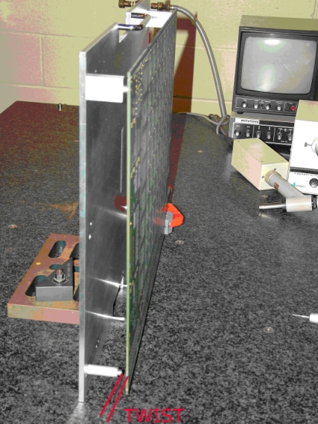
Figure 1: Setup on CMM for twist measurement. Only 3 corners are constrained to the reference plane formed by the posts mounted to the press fit plate
Table 4 Test Equipment Detail
Description | Model | Manufacturer | Equip. Serial Number | AM Number | Calibration Valid (MM/DD/YY) | Location of Equipment
Coordinate Measurement Machine | B-241 | Mitutoyo | 8405276 (unit)  3010346 (counter) | CMM-1 | 03/05/2010 | Breconridge

Results
The limit for both bow and twist is 0.75% for surface mount PWBs per IPC 2221. The same guideline was used for the assembled CCA even though IPC 2221 applies only to bare PWB’s. Any boards that exceed this limit are highlighted in red text in the following table. Some of the Pre-SMT and post-SMT bow and twist values are higher than expected. The Post-SMT specification is a guideline but care should be taken when clamping the boards into the system to ensure minimum stress is projected onto the solder joints of the components.
The bow measurements were done using the following orientation of the PWB. The NRC-CNRC label is on the opposite side. The positive X direction is towards the right.
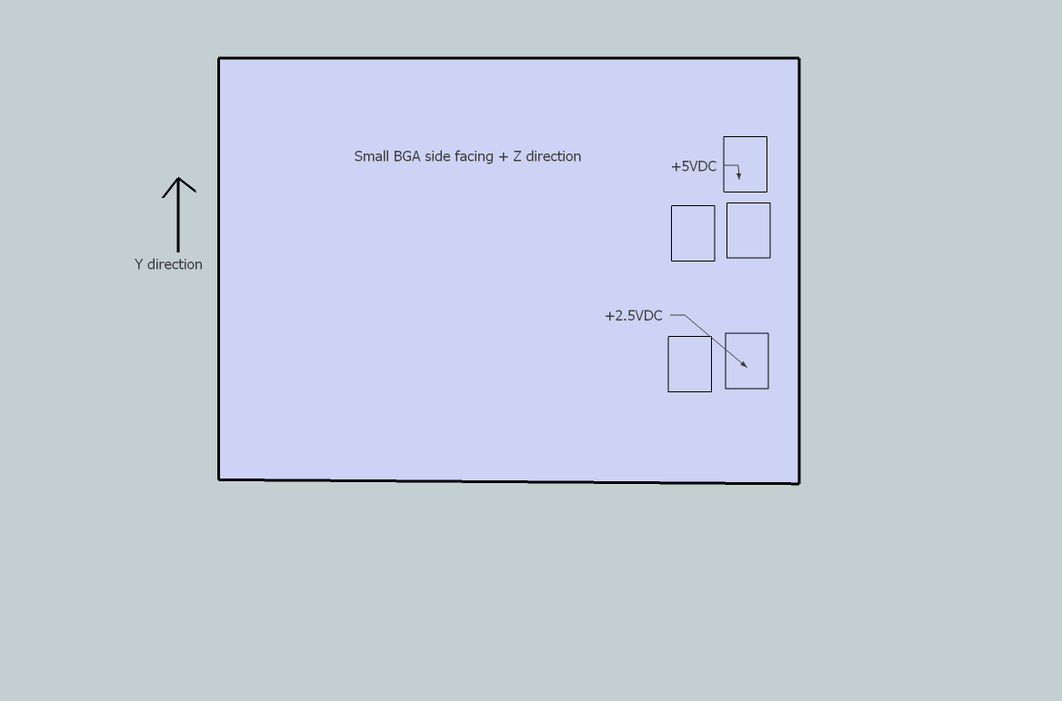
Figure 2: Orientation for the Warp and Twist Measurement
For all three boards the twist improved after assembly. Even the board 2 which had excessive twist prior to assembly had acceptable twist after assembly.
Three dimensional plots of the bow measurements before and after assembly are shown in Figures 3 to 5. Prior to assembly, all three boards had acceptable bow. Boards 1 and 3 had a convex shape whereas Board 2 and a concave shape. After assembly the initial shapes where exaggerated with the bow increasing for all three boards. The amount of bow exceeded the desired limit for both Boards 3 and 1 and was close to the limit for Board 2. It must be remembered that this is only a recommendation and not a hard requirement after assembly.
Table 5: Bow and Twist Testing Results
Board | Assembly Status | Spec. | Bow |  | Twist
Board | Assembly Status | Spec. | R_{L} | R_{w} | Twist
Board1 | Pre-SMT | 0.75% | 0.45% | 0.57% | 0.38%
 | Post-SMT | 0.75% | 0.70% | 0.88% | 0.09%
Board2 | Pre-SMT | 0.75% | 0.30% | 0.38% | 0.85%
 | Post-SMT | 0.75% | 0.57% | 0.72% | 0.35%
Board3 | Pre-SMT | 0.75% | 0.31% | 0.39% | 0.38%
 | Post-SMT | 0.75% | 0.79% | 0.99% | 0.15%

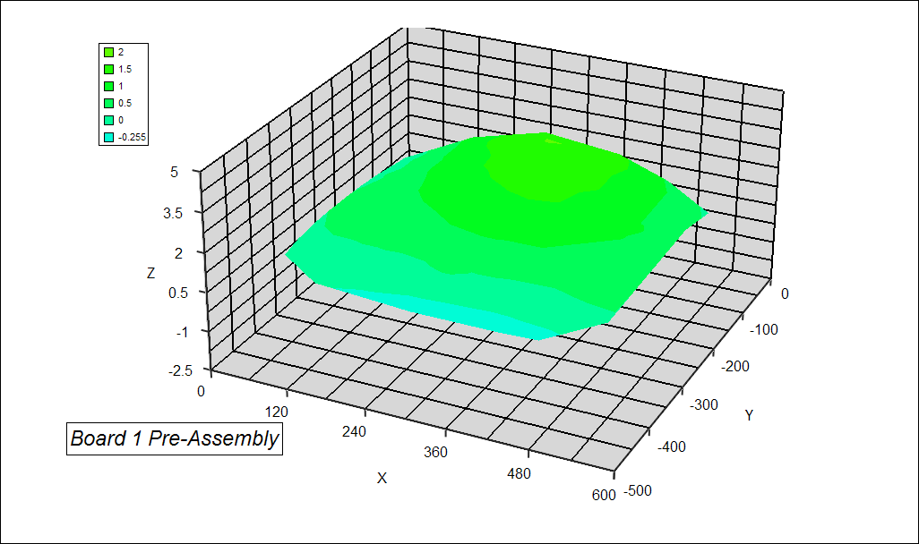
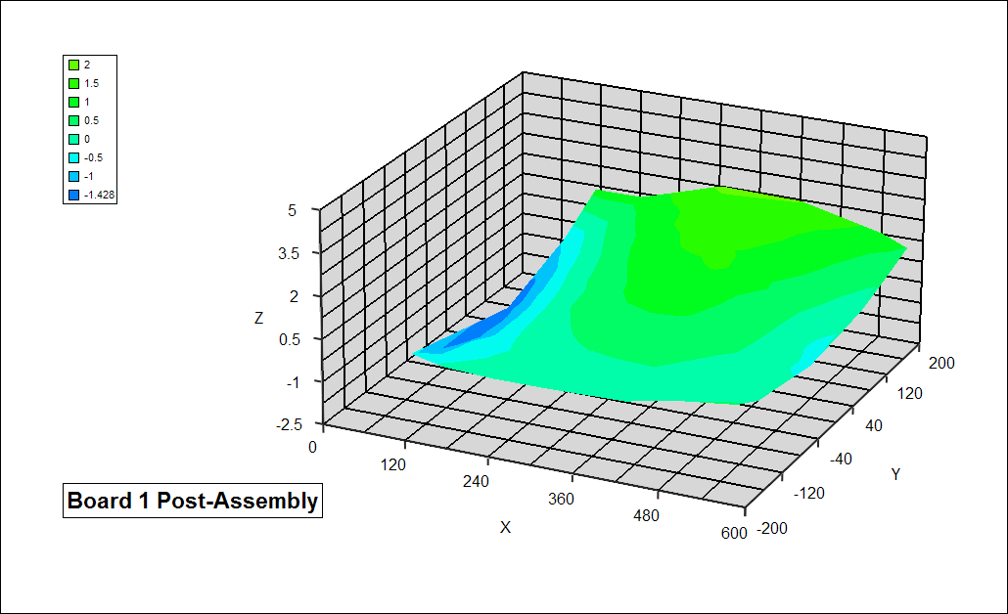
Figure 3: Bow of Board 1 Pre and After Assembly, dimensions in mm.

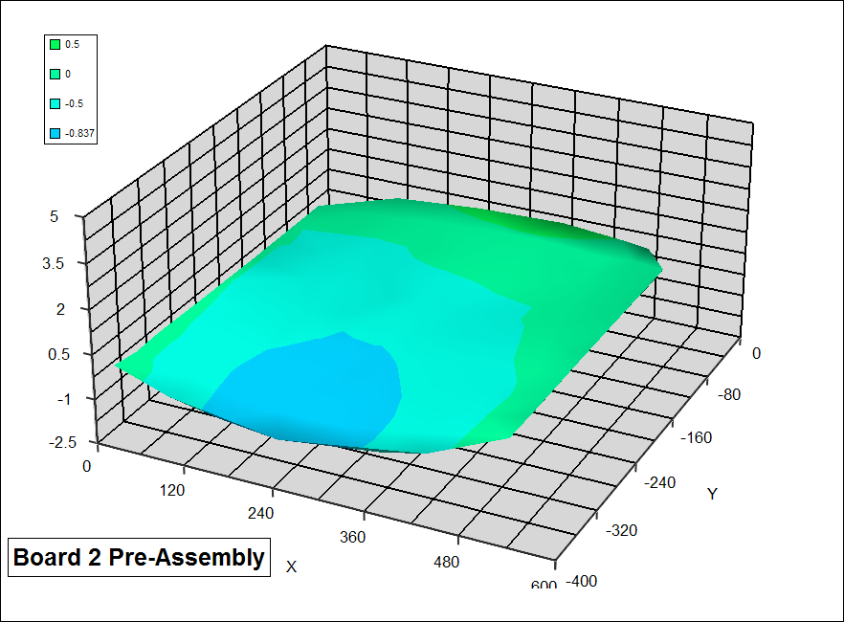
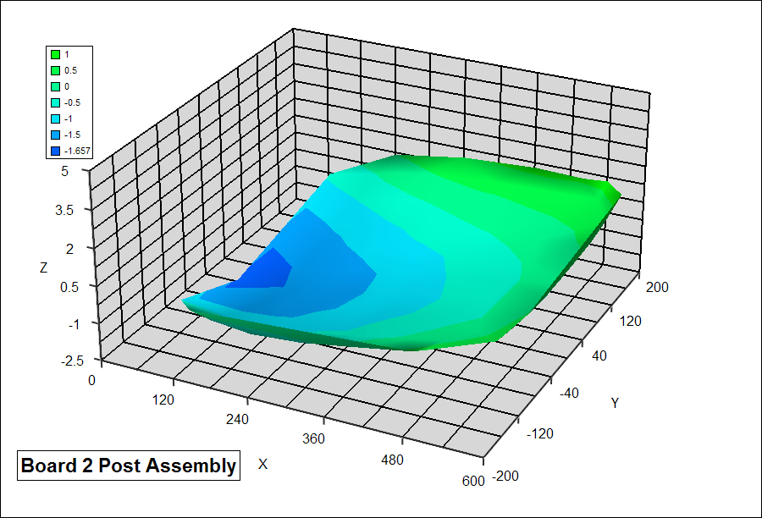
Figure 4: Bow of Board 2 Pre and Post Assembly, dimensions in mm
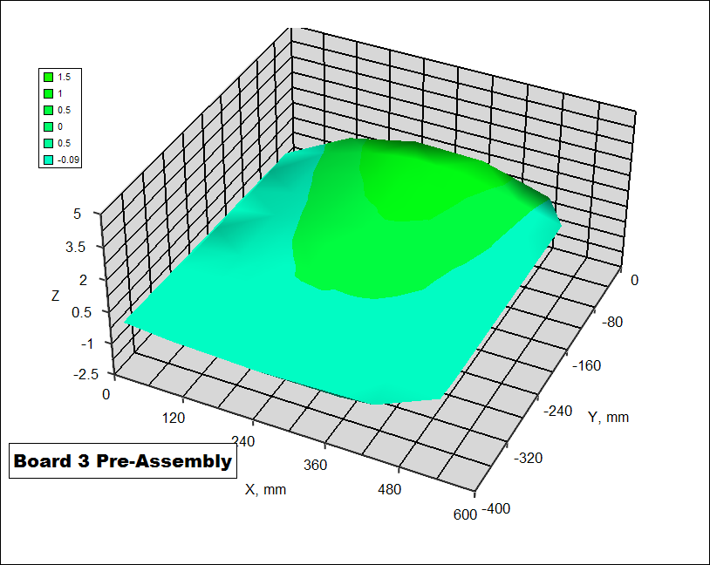
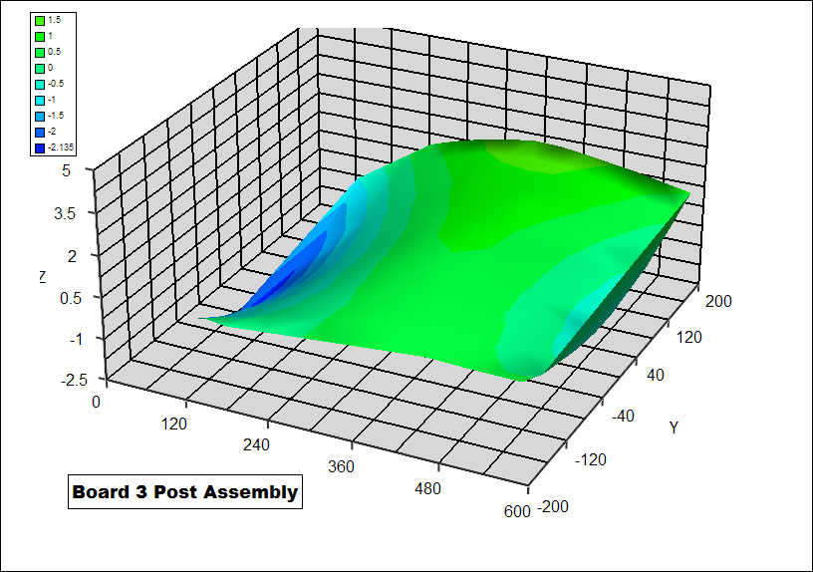
Figure 5: Bow of Board 3 Pre and Post Assembly, dimensions in mm

Discussion
The as-received PWB’s meet the IPC 2221 specifications for bow for all three boards and twist for 2 out of 3 boards. The excessive twist did not seem to cause a problem during assembly as all the assembled boards had acceptable twist after assembly.
The increase in bow after SMT may induce an increase the stress in the BGA solder joints when the board assembly is fastened into the chassis. This should be kept in mind when evaluating the overall assembly. The acceptable bow after SMT depends upon the end application and next level assembly.
The source of this increased bow is not clear as it seems to be related to the initial shape of the PWB prior to SMT assembly. The stress states of the assembled PWB is very complex with the PWB stackup, imbalance in the component density on both side of the PWB and the supporting framework during SMT reflow all playing a role.

IST TESTING

IST TESTING APPROACH
Interconnect stress testing (IST) is a relatively new method to determine the resistance of both plated through hole and via interconnect to temperature cycling. A controlled DC current is used to self heat the daisy chained interconnect on specially designed coupons that represent the PWB technology being evaluated. By increasing and decreasing the current in the circuit, the temperature of the PWB can be cycled between ambient and the maximum test temperature, typically 150°C. During the maximum temperature excursions interconnect electrical resistances are monitored. Increases in resistance indicate the development of cracking in the interconnect structure. Typically resistance increases of about 10% are considered as failures.
Prior to the beginning of the IST testing phase, the IST coupons are pre-tested by heating to 230°C for six cycles to simulate the conditions that the boards undergo at assembly process.
IST testing was performed by on 24 coupons to represent the same via structures as found in the baseline board design. The coupon designs for the component PTH, via PTH, and blind vias are detailed in Table 5
Table 6: IST Test Coupon Design
PTH Type | Layers | Drill  Diameter | Pad  Diameter | Pitch Between Holes | Notes
Component PTH | 1-28 | 0.028”  AR: 4.5 | 0.0394” | 0.075” | Single Sense design
Via PTH | 1-28 | 0.0118”  AR: 10.7 | 0.0218” | 0.033” | Single Sense design
Blind Via | 1-14 | 0.0098”  AR: 6.1 | 0.0218” | 0.033” | Single Sense design
Blind Via | 15-28 | 0.0098”  AR: 6.1 | 0.0218” | 0.033” | Single Sense design
AR [=] Aspect Ratio
The resistance data for the IST coupons are detailed in Table 7 to 10 below. The rows highlighted were IST coupons that were chosen for stress testing, these coupons typically were close to the mean resistance for all of the coupons. Note the tight distribution in resistance values indicating good process control in the manufacture of the coupons. The acronym DHS stands for Drilled Hole Size (Drilled Hole Diameter).
Table 7: Resistance Pre-screen Data for 0.028” DHS
Coupon ID. | Post Resistance | PTH Resistance
1281 | 616 | 239
1282 | 621 | 241
1283 | 617 | 241
1284 | 622 | 241
1285 | 622 | 239
1286 | 622 | 241
1287 | 619 | 240
1288 | 617 | 239
1289 | 619 | 241
12810 | 618 | 240
12811 | 618 | 241
12812 | 621 | 241
2281 | 618 | 240
2282 | 619 | 241
2283 | 619 | 241
2284 | 621 | 241
2285 | 622 | 240
2286 | 623 | 242
2287 | 623 | 241
2288 | 619 | 239
2289 | 619 | 242
22810 | 621 | 241
22811 | 619 | 241
22812 | 623 | 240
3281 | 617 | 240
3282 | 617 | 238
3283 | 622 | 240
3284 | 622 | 241
3285 | 620 | 239
3286 | 618 | 239
3287 | 617 | 239
3288 | 621 | 239
3289 | 624 | 241
32810 | 621 | 239
32811 | 619 | 240
32812 | 620 | 240
Mean | 619.9 | 240.2
StDev | 2.12 | 0.99
Min | 616 | 238
Max | 624 | 242
Range | 8 | 4
Table 8:Resistance Prescreen Data for 0.0118” DHS
Coupon ID. | Post Resistance | PTH Resistance
1121 | 716 | 422
1122 | 704 | 418
1123 | 710 | 420
1124 | 708 | 420
1125 | 713 | 423
1126 | 710 | 417
1127 | 710 | 422
1128 | 716 | 422
1129 | 720 | 417
11210 | 720 | 419
11211 | 712 | 421
11212 | 704 | 417
2121 | 710 | 417
2122 | 711 | 418
2123 | 716 | 418
2124 | 714 | 419
2125 | 708 | 414
2126 | 704 | 415
2127 | 713 | 417
2128 | 709 | 416
2129 | 715 | 420
21210 | 711 | 415
21211 | 712 | 420
21212 | 710 | 424
3121 | 709 | 409
3122 | 709 | 411
3123 | 709 | 417
3124 | 712 | 412
3125 | 710 | 414
3126 | 707 | 413
3127 | 711 | 416
3128 | 712 | 410
3129 | 713 | 410
31210 | 717 | 412
31211 | 712 | 410
31212 | 715 | 412
Mean | 711.6 | 416.6
StDev | 3.69 | 4.08
Min | 704 | 410
Max | 720 | 423
Range | 16 | 13
Table 9: Resistance Prescreen Data for 0.0098” DHS Blind Via for Layers 1-14
Coupon ID. | Post Resistance | PTH Resistance
1101 | 769 | 346
1102 | 767 | 347
1103 | 774 | 350
1104 | 768 | 346
1105 | 773 | 342
1106 | 774 | 344
1107 | 782 | 346
1108 | 772 | 343
1109 | 770 | 346
11010 | 774 | 340
11011 | 778 | 344
11012 | 772 | 345
2101 | 757 | 333
2102 | 778 | 344
2103 | 775 | 345
2104 | 773 | 344
2105 | 771 | 343
2106 | 765 | 339
2107 | 773 | 343
2108 | 775 | 342
2109 | 767 | 339
21010 | 769 | 342
21011 | 762 | 337
21012 | 778 | 340
3101 | 773 | 346
3102 | 773 | 345
3103 | 785 | 349
3104 | 782 | 346
3105 | 779 | 342
3106 | 782 | 348
3107 | 782 | 347
3108 | 780 | 345
3109 | 775 | 343
31010 | 773 | 344
31011 | 775 | 349
31012 | 775 | 347
Mean | 773.6 | 343.9
StDev | 5.91 | 3.50
Min | 757 | 333
Max | 785 | 350
Range | 28 | 17
Table 10: Resistance Prescreen Data for 0.0098” DHS Blind Via for Layers 15-28
Coupon ID. | Post Resistance | PTH Resistance
1101 | 777 | 362
1102 | 769 | 359
1103 | 765 | 354
1104 | 768 | 355
1105 | 764 | 353
1106 | 772 | 356
1107 | 765 | 354
1108 | 762 | 352
1109 | 765 | 354
11010 | 771 | 356
11011 | 765 | 354
11012 | 766 | 354
2101 | 765 | 350
2102 | 771 | 355
2103 | 769 | 353
2104 | 772 | 353
2105 | 766 | 350
2106 | 768 | 350
2107 | 767 | 349
2108 | 770 | 351
2109 | 771 | 358
21010 | 771 | 354
21011 | 782 | 360
21012 | 767 | 351
3101 | 771 | 354
3102 | 765 | 350
3103 | 767 | 355
3104 | 777 | 362
3105 | 774 | 356
3106 | 765 | 348
3107 | 765 | 348
3108 | 765 | 350
3109 | 762 | 349
31010 | 766 | 349
31011 | 770 | 353
31012 | 766 | 351
Mean | 768.4 | 353.4
StDev | 4.36 | 3.66
Min | 762 | 348
Max | 782 | 362
Range | 20 | 14

IST test condition
The 24 selected coupons were exposed to IST Assembly Conditioning per Table 11 and IST Test parameters per Table 12.
Table 11: IST Assembly Conditioning
Number of IST Cycles | 6
Test Temperature | 230°C
Compensation | Yes
Precycle Time Window | 3 seconds
% Reject Power | 10

Table 12: IST Test Conditions
Number of IST Cycles | 500
MaxTest Temperature | 150°C
Min. Test Temperature | 25°C
Delta Temperature | 125°C
Data Recorded Every ? Cycles | 25
Compensation | Yes
Pre-cycle Time Window | 3 seconds
% Reject Power | 10
% Reject Sense | 10

IST test Results
No failures were found during IST testing. There was negligible change in the resistance values for all 4 test coupon types evaluated. This indicates that little or no cracking occurred during the stress testing.
The tabulated IST results are in Table 13 to 16. The resistance change graphs are in Figures 6 to 9.
Table 13: IST Results for 0.028” DHS
Test  Condition | Coupon  ID | Post  Cycles | Post  % | PTH  Cycles | PTH  % | Failure Mode
6X@230C | 1282 | 500 | 0.0 | 500 | 0.0 | No Failure
6X@230C | 12811 | 500 | 0.0 | 500 | 0.0 | No Failure
6X@230C | 2286 | 500 | 0.0 | 500 | 0.0 | No Failure
6X@230C | 2289 | 500 | 0.0 | 500 | 0.0 | No Failure
6X@230C | 3284 | 500 | 0.0 | 500 | 0.0 | No Failure
6X@230C | 3289 | 500 | 0.0 | 500 | 0.0 | No Failure
Mean |  | 500 | 0.0 | 500 | 0.0 | All Suspend Data
StDev |  | 0.0 | 0.0 | 0.0 | 0.0
Min |  | 500 | 0.0 | 500 | 0.0
Max |  | 500 | 0.0 | 500 | 0.0
Range |  | 0 | 0.0 | 0 | 0.0

Table 14: IST Results for 0.0118” DHS
Test  Condition | Coupon  ID | Post  Cycles | Post  % | PTH  Cycles | PTH  % | Failure Mode
6X@230C | 1125 | 500 | 0.0 | 500 | 0.0 | No Failure
6X@230C | 1128 | 500 | 0.0 | 500 | 0.0 | No Failure
6X@230C | 21211 | 500 | 0.0 | 500 | 0.0 | No Failure
6X@230C | 21212 | 500 | 0.0 | 500 | 0.0 | No Failure
6X@230C | 3123 | 500 | 0.0 | 500 | 0.0 | No Failure
6X@230C | 3127 | 500 | 0.0 | 500 | 0.0 | No Failure
Mean |  | 500 | 0.0 | 500 | 0.0 | All Suspend Data
StDev |  | 0.0 | 0.0 | 0.0 | 0.0
Min |  | 500 | 0.0 | 500 | 0.0
Max |  | 500 | 0.0 | 500 | 0.0
Range |  | 0 | 0.0 | 0 | 0.0

Table 15: IST Results for 0.0098” DHS Blind Via for Layers 1-14
Test  Condition | Coupon  ID | Post  Cycles | Post  % | PTH  Cycles | PTH  % | Failure Mode
6X@230C | 1103 | 500 | 0.0 | 500 | 0.0 | No Failure
6X@230C | 1109 | 500 | 0.0 | 500 | 0.0 | No Failure
6X@230C | 2103 | 500 | 0.0 | 500 | 0.1 | No Failure
6X@230C | 2107 | 500 | 0.2 | 500 | 0.1 | No Failure
6X@230C | 3103 | 500 | 0.1 | 500 | 0.0 | No Failure
6X@230C | 31011 | 500 | 0.2 | 500 | 0.2 | No Failure
Mean |  | 500 | 0.08 | 500 | 0.07 | All Suspend Data
StDev |  | 0.0 | 0.04 | 0.0 | 0.03
Min |  | 500 | 0.0 | 500 | 0.0
Max |  | 500 | 0.2 | 500 | 0.2
Range |  | 0 | 0.2 | 0 | 0.2

Table 16: IST Results for 0.0118” DHS Blind Via for Layers 15-28
Test  Condition | Coupon  ID | Post  Cycles | Post  % Resistance Change | PTH  Cycles | PTH  % | Failure Mode
6X@230C | 1101 | 500 | 0.0 | 500 | 0.0 | No Failure
6X@230C | 1102 | 500 | 0.0 | 500 | 0.2 | No Failure
6X@230C | 2109 | 500 | 0.0 | 500 | 0.0 | No Failure
6X@230C | 21011 | 500 | 0.0 | 500 | 0.0 | No Failure
6X@230C | 3104 | 500 | 0.0 | 500 | 0.0 | No Failure
6X@230C | 3105 | 500 | 0.0 | 500 | 0.1 | No Failure
Mean |  | 500 | 0.0 | 500 | 0.05 | All Suspend Data
StDev |  | 0.0 | 0.0 | 0.0 | 0.08
Min |  | 500 | 0.0 | 500 | 0.0
Max |  | 500 | 0.0 | 500 | 0.2
Range |  | 0 | 0.0 | 0 | 0.2

Figure 6: Component PTH Assembly Conditioning: Ambient to 230°C for 6 IST cycles

Figure 7: Via PTH Assembly Conditioning: Ambient to 230°C for 6 IST cycles

Figure 8: Blind Via Layers 1-14 Assembly Conditioning: Ambient to 230°C for 6 IST cycles
Drill Hole Size 0.0098”

Figure 9: Blind Via Layers 15-28 Assembly Conditioning: Ambient to 230°C for 6 IST cycles
Drill Hole Size: 0.0098”

IST test Coupon cross section
Crosse section analysis was conducted on both untested and tested IST coupons. The PTHs and vias of all four types of coupons were evaluated. Little difference was found between the untested and thermally cycled coupons. No barrel cracks or cracking at surface lands or inner layers were detected. This confirms the results of the IST resistance measurements. Cross-section images are shown in Figure 10 to Figure 13.
.

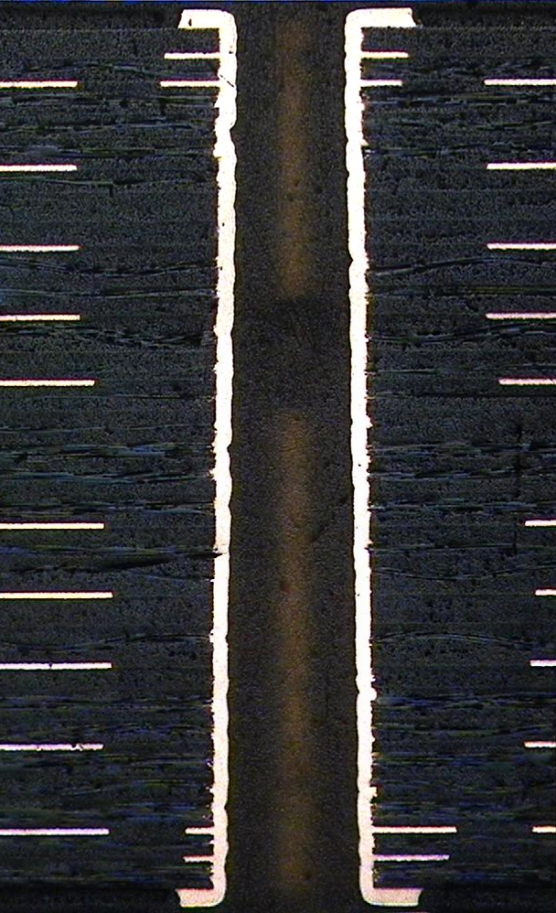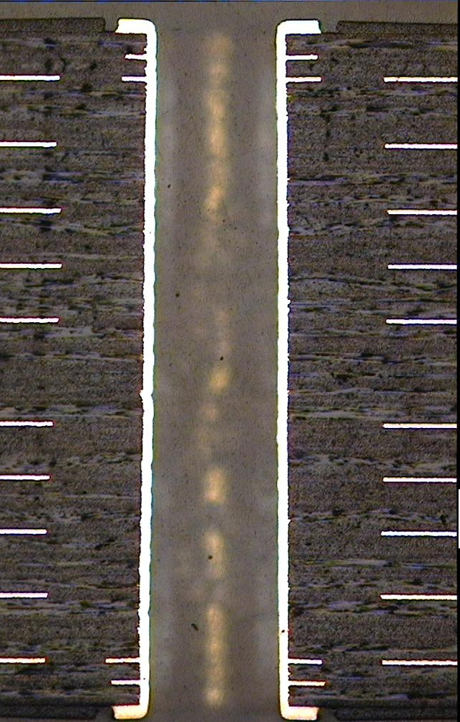
Figure 10 (A) PTH image of an untested coupon (B) PTH image of a tested coupon, 500 thermal cycles

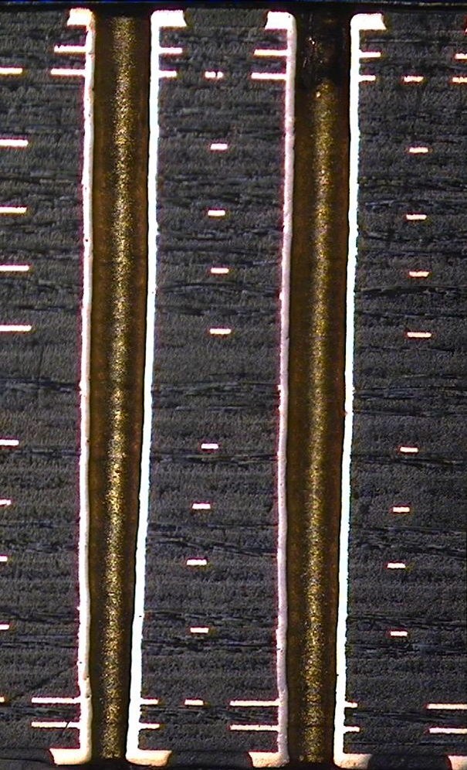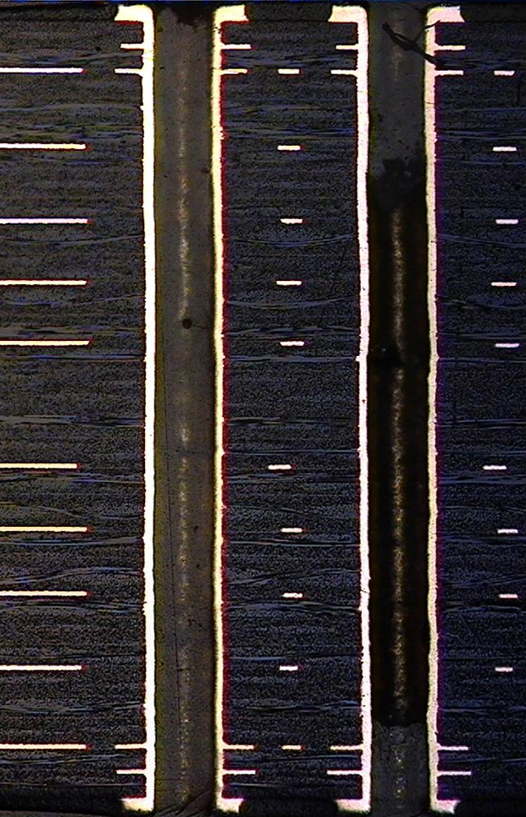
Figure 11 (A) Via PTH image of an untested coupon (B) Via PTH image of a tested coupon, , 500 thermal cycles

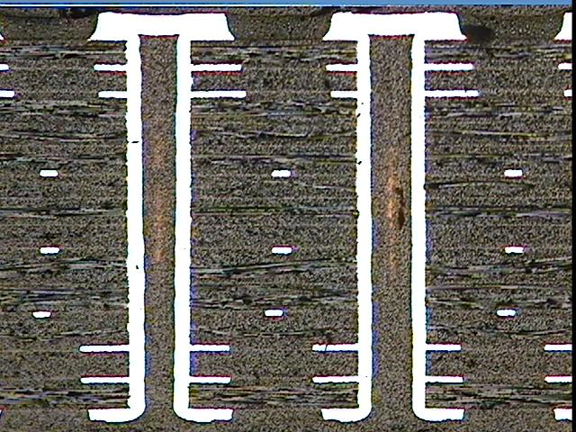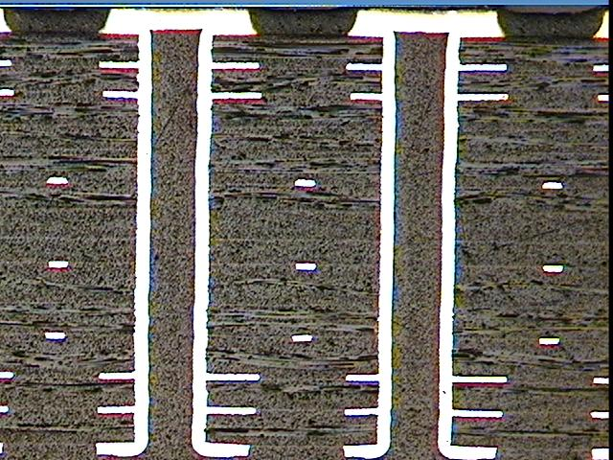
Figure 12 (A) Blind via (1-14) image of an untested coupon (B) Blind via (1-14) image of a tested coupon, ,500 thermal cycles

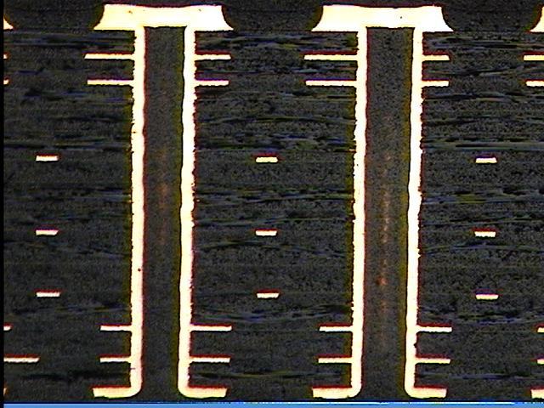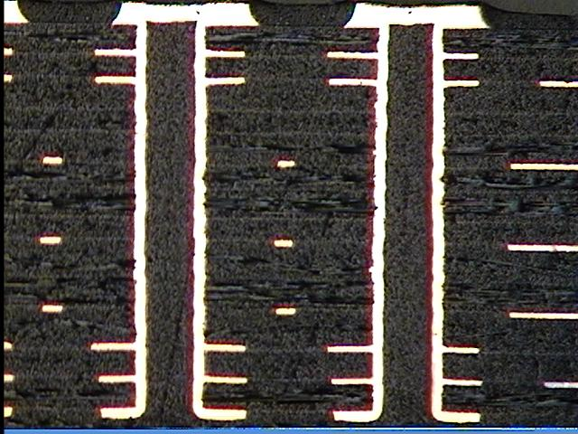
Figure 13 (A) Blind via (15-28) image of an untested coupon (B) Blind via (15-28) image of a tested coupon, , 500 thermal cycles

conclusion
- The IPC testing performed by Merix and data demonstrates their PWB manufacturing compliance to IPC 6012.
- The Merix boards had acceptable as-received bow and only slightly exceed the twist limit for one out of three PWB’s (IPC 2221). This did not cause any issues during SMT assembly.
- After SMT assembly, the bow did increase. Whether this will have negative impact will have to be determined at the next level assembly. If this does prove to be an issue, further evaluation of the board design and SMT assembly process will be required.
- IST testing was performed on four types of IST coupons which included PTH, via and blind via structures. These coupons use the same drill sizes and PWB stack-up that was used for the Baseline board manufacture. No failures, significant resistance changes or interconnect cracking were found during or after testing. These results demonstrate the robustness of the PWB technology used to manufacture the Baseline boards.

