DOPPLER SHIFT IN THE MILKY WAY

An instructional unit produced by
Shawn Price and Elissa Thorn
ST562 Radio Astronomy for Teachers
Summer 2006

Overview

Students will explore how the Doppler Effect can be used to investigate the motion of material in our home galaxy, the Milky Way.

Intended Audience

This unit is designed to target the more intellectually sophisticated students in Shawn’s 8th grade Physical Science classes and the less mathematically competent students in Elissa’s 9th grade Conceptual Physics classes. However, this unit should be accessible to all 8th and 9th graders if suitable minor adjustments are made as necessary.

Prerequisite Knowledge

Throughout this unit, we assume that students already have at least rudimentary knowledge of the following concepts:

Relative Motion
Reference Frames
Vector Addition and Subtraction
(graphical “head-to-tail” method)
Vector Components
Gravitation and Orbits
Wave Motion
(including the wave speed equation, v=λf)
Electromagnetic Spectrum
Atomic Emission and Absorption Spectra
Doppler Effect

No trigonometry or advanced algebra is used in this unit. Vectors are treated qualitatively rather than quantitatively. Students should be familiar with creating and interpreting basic x-y graphs.

Goals/Objectives

Due to the extensive prerequisites listed above, this unit is intended to serve as a cap-stone experience toward the end of the school year. Both Shawn and Elissa teach relative motion, reference frames, and vectors early in the year, gravitation and orbits mid-year, and waves (including atomic spectra and the Doppler Effect) late in the year (with other traditional physics/physical science topics interspersed, of course). Therefore, this unit provides an opportunity to pique students’ interest with “cool space stuff” while reinforcing (and expanding upon) a wide range of previously introduced material. Students will apply prior knowledge to a new situation, solidifying their understanding.

In addition, it is our hope and intention that this unit will challenge students to visualize different points of view from different reference frames; provide practice in representing data graphically and interpreting graphs; give students a real-world example of how scientists apply physics principles to study our galaxy; and arouse students’ interest in and curiosity about our galaxy.

“Doppler Shift in the Milky Way” Unit Contents

Lesson One: Visiting Vectors Vigorously
Practice problems and concept development problems regarding vector addition, subtraction, and components

Lesson Two: Digging Deeper Into Doppler
Demos exploring the Doppler Effect’s line-of-sight dependence

Lesson Three: Galactic Gallivanting
Review of orbital motion, introduction of Galactic coordinates and the Local Standard of Rest (LSR), a kinesthetic activity demonstrating Galactic motions relative to the LSR, and a graphing exercise

Lesson Four: Hydrogen Hi-jinks
Introduction of hydrogen’s 21-cm (1420.4 MHz) emission line and discussion of how actual Galactic hydrogen spectra are used to study Galactic motion

*Note: Lessons are not of equal length; some will take more time than others.
Lesson One: Visiting Vectors Vigorously

Objective: to review vector addition, subtraction, and components in the context of new, more challenging problems that will prepare students for lessons 2 and 3.

Presented in the form of a worksheet to be completed in small groups, or as a guided whole-class discussion.
(answers in red)

PART ONE

1. Suppose you are driving a Hummer down the highway. Coming head-on toward you is a Porsche trying to pass a slow truck. Your speed is 60 mi/h, and the Porsche is going 80 mi/h.
a) Draw a picture of this situation, and include vectors representing your velocity and the Porsche’s velocity.

Hummer 60 mi/h 80 mi/h Porsche

b) How fast is the Porsche moving relative to you? Is it moving toward or away from you? Draw a vector to represent the Porsche’s velocity relative to you.
140 mi/h, toward

140 mi/h

c) Draw a picture showing how to use addition or subtraction of vectors to produce the vector that represents the Porsche’s velocity relative to you (your answer to part b). Then write an equation that matches your picture.
Let Hummer velocity vector be named A, Porsche velocity vector be named B, and resultant Porsche velocity vector relative to the Hummer be V.

A (60mi/h) B (80mi/h)

V (140mi/h)
B-A=V or B+(-A)=V

d) Was this problem about vector addition or subtraction?
vector subtraction, OR addition of an opposite vector (must subtract your motion from the motion of the object you are trying to find the velocity of)

2. Continuing down the highway, you notice an intersection ahead, with lots of cross traffic. As you approach the intersection, an ambulance passes through the intersection on the cross street. (See diagram, below.)

Hummer, moving forward as time progresses
Ambulance, moving forward as time progresses

a) Find the vector (magnitude and direction) that represents the ambulance’s velocity relative to you for each point in time shown. Show your work!
Let Hummer’s velocity be A, ambulance’s velocity be B, and resultant bus’s velocity relative to Hummer be V.

First moment (ambulance at bottom of diagram, above):
A
V
B

Next moment: Same diagram!
Next moment (ambulance in middle of intersection): Same diagram!
Next moment: Same diagram!
Last moment (ambulance at top of diagram): Same diagram! Amazing!

b) Did you add or subtract vectors in (a)?
subtract (or add the opposite of) the Hummer’s velocity vector
c) Describe what happened to the ambulance’s velocity vector (relative to you) as the ambulance moved through the intersection.
Nothing!
d) Draw the vector you found in (a) on the diagram below. (Place the TAIL of the vector at the position of the ambulance.)

Hummer, moving forward as time progresses
Ambulance, moving forward as time progresses

e) Using a dashed line, draw a line starting at your position (the position of the Hummer) and passing through the position of the ambulance. Now draw another dashed line, perpendicular to the first dashed line, passing through the position of the ambulance. (You have just created a new coordinate system relating you and the ambulance!)

f) Draw the components of the ambulance’s velocity (relative to you) IN THIS NEW COORDINATE SYSTEM. Notice that one component represents the ambulance’s velocity directly toward or away from you (ALONG your line of vision), and the other component represents the ambulance’s motion ACROSS your line of vision.
(Answer is in green…too many red lines)
g) Is the ambulance moving faster along your line of vision or across your line of vision? How do you know?
along…that component of the velocity vector is longer
h) Follow the same procedure of (d), (e), and (f), above, for each subsequent position of your Hummer and ambulance.
Hummer, moving forward as time progresses
Ambulance, moving forward as time progresses

i) In general, what happens to the component of velocity ALONG your line of vision as the ambulance moves from one side of the intersection to the other? (We are ignoring the component of velocity ACROSS your line of vision for the time being, for reasons that will become clear in the next lesson.)
The component of velocity along the Hummer’s line of vision DECREASES as the ambulance moves toward the intersection. (Compare the answer to (f) with the answer for the 2nd and 3rd positions of the ambulance.) Eventually (but unfortunately long after the times shown in this diagram), the component of velocity along the Hummer’s line of vision will increase again. (If we had time, we would rework this diagram to better illustrate our point. Basically, the Hummer needs to move through and past the intersection. Feel free to play around with this and come up w/ a better diagram on your own! You’ll learn a lot about the situation by doing that, for sure.)
j) Where are the ambulance and Hummer at the moment there is NO velocity component of the ambulance’s motion relative to the Hummer ALONG the Hummer’s line of vision?
Hummer will be approaching the intersection, ambulance will be farther up the page (farther north), in the right positions such that the line joining the Hummer and ambulance is exactly perpendicular to the vector representing the ambulance’s velocity relative to the Hummer.

PART TWO

Just for fun, you take your Hummer to the local race track, which just happens to be round (not oval) and contains several parallel lanes. There are several other vehicles at a variety of positions on the track, moving around the track in their respective lanes, as shown below. (Terrible diagram…sorry. If you draw your own, make the circles concentric and be sure to vary the magnitudes of the tangential velocities of the other vehicles.)
Hummer (YOU!)

1. For each vehicle, find the vector that represents that vehicle’s velocity relative to you, and draw this vector on the diagram above, placing the vector’s tail at the position of the vehicle.
(Only a few are done for you this time.)
2. For each of the vectors you found in number 1, draw the components along and across your line of sight.
(Only a few are done for you this time.)
3. Which vehicle is moving the fastest ALONG your line of sight?
Whichever has the longest component of velocity (relative to you) along your line of sight.
4. Which vehicles are not moving at all along your line of sight?
Whichever have velocities (relative to you) perpendicular to your line of sight.

IMPORTANT TAKE-HOME POINTS for Lesson One:

1) If you know your velocity relative to the ground and you know the velocity of something else relative to the ground, what general procedure do you use to find the velocity of that something else RELATIVE TO YOU? Subtract your own velocity vector from the other object’s velocity vector.
2) You need to be able to visualize the components of another object’s velocity vector relative to you in terms of “along your line of sight” and “across your line of sight”. For our current purposes, as you will see in the next lesson, the component ALONG is most important.

Lesson Two: Digging Deeper Into Doppler

Objective: to review the Doppler Effect, with special emphasis on the fact that the Doppler Effect applies ONLY to the component of motion directly toward or away from the observer.

1. Review: The Doppler Effect is a shift in frequency due to motion of the source or observer. It applies to ALL types of waves (electromagnetic waves, sound, water, etc.). For visible light, the Doppler effect causes a change in color: red shift for motion away (decrease in observed frequency), or blue shift for motion toward (increase in observed frequency). The terms “red shift” and “blue shift” may be generalized to apply to any frequency range in the electromagnetic spectrum. Frequency and wavelength are related via the wave speed equation, v=λf. If frequency increases, wavelength decreases, and vice versa.

2. Demonstration/Activity: If you whirl a tethered noisemaker in large horizontal circle around your head, YOU can’t hear the Doppler shift, but everybody else can. The noise maker is staying a constant distance from YOU (and hence not moving relative to you), but it is moving alternately toward and away from everybody else as it orbits. (Let as many students as possible take a turn at this to experience the lack of Doppler shift.)

Note: This apparatus can be easily built from a small battery powered buzzer or mechanical alarm clock attached to a 1-2m length of light rope. Some people pad the noisemaker/battery assembly by imbedding it within a foam ball.

3. Demonstration/activity: Doppler Java applet

http://www.lon-capa.org/~mmp/applist/doppler/d.htm

Create a source moving from left to right at approximately Mach 0.8. Pause the simulation when the source is about 75% across the window and sketch what you see.

Draw different lines of sight to observe the wavelength at different angles to the direction of travel. When you look along a line of sight perpendicular to the direction of the motion of the source, you should be able to see that the wavelength (and hence frequency) is the same as it would be if the source were stationary. You should also be able to see that the Doppler Effect is most pronounced when viewed along a line of sight parallel to the motion of the source.

4. Discussion: Refer back to Lesson One. In which positions would the ambulance’s siren have been most and least Doppler shifted? In the case of the circular race track, which vehicles’ engine noise would have been most and least Doppler shifted? Why? (And can you now see why we were so concerned with resolving the velocity vectors into components along and across the line of sight?)

Lesson Three: Galactic Gallivanting

Objective: to develop an understanding of Galactic motion as seen from the “Local Standard of Rest” reference frame

1. Review:
a) Expanding our view outward
We live on the Earth, which orbits around the Sun. The Sun, in turn, orbits around the center of the Milky Way Galaxy. (The Milky Way Galaxy is a big clump of stars, gas, and dust, somewhat arranged in spiral arms, all orbiting a massive black hole in the center.) The Milky Way Galaxy is just one of many, many galaxies and other structures moving through the Universe. (Sometimes, whole galaxies collide!)
b) Gravitation and orbits
Gravity obeys an inverse square relationship, so the farther away you get from a massive object, the less gravity you will feel. Therefore, if you try to construct a solar system with circular planetary orbits, planets closer to the central star will need faster tangential velocities (in order to avoid being sucked into the star) than planets farther away (which will need slower tangential velocities to avoid being flung out of orbit).

2. Discussion/lecture:
a) Galactic coordinates
Imagine a globe with lines of latitude and longitude on its surface. Now imagine a bright light inside the globe projecting these lines out into space. (It helps if you have one of those nice celestial globes to show this with…you know, the big clear balls with constellations printed on them and an Earth inside. ☺) This new grid of lines is a way of describing a location on the celestial sphere relative to Earth’s equatorial plane. This equatorial system works fine for identifying locations from an Earth-centered frame, but what if we want to look at things from a broader perspective? For this, we might choose to use Galactic coordinates. In a Galactic reference frame, we still imagine lines projected outward from our planet, but now the ‘equator’ is lined up with the Galactic plane (what we see as the band of the Milky Way at night) rather than the Earth’s equator. This projected grid of lines gives us Galactic longitude and latitude, where 0 degrees longitude corresponds to the direction in which the Galactic center lies.

b) The Local Standard of Rest (LSR)
When observing the motion of objects within our Galaxy, things get complicated fast. We’re riding on the Earth, which is orbiting the Sun, and our entire solar system is orbiting the black hole at the center of the Milky Way. Try picturing what our path through the Milky Way actually looks like, what with all that meta-orbiting! Thankfully, the LSR provides a convenient reference frame from which to view the Galaxy.
To establish the LSR, imagine the Sun following a perfect circular orbit around the center of the Galaxy. Now imagine our entire solar system as one glob of stuff surrounding the Sun, tracing out a perfect circular orbit around the center of the Galaxy. If we take a reference frame, centered on the Sun, that follows this circle around the Galaxy, we have our Local Standard of Rest (LSR). On average, nearby stars will not be moving relative to the LSR because they should be orbiting at the same tangential speed as the Sun (since they reside at approximately the same radial distance from the Galactic center of mass). Therefore, you can think of the LSR as a clump of nearby stars all riding around the Galaxy together. Picture the rest of the Galaxy moving past you as you ride along with this clump of stars, much like the countryside moves past you as you ride in a car.
Optional tangent: The idea of LSR is complicated by the fact that the Sun doesn’t follow this ideal circular path. Thus, the Sun’s motion with respect to the LSR has a velocity we refer to as V_{LSR}. To properly account for this when looking out into the Galaxy, we subtract the component of VLSR that is aligned with the direction in which we are observing (analogous to what we did in Lesson One).

3. Activity: Galactic motion relative to the LSR
Take students outside or to a place with a lot of clear floor space (the gym, etc). Divide students into groups of three to five. (Each group constitutes one copy of the Milky Way Galaxy.) For each group, designate a tree, garbage can, or chair (etc) as the center of the Galaxy and assign one student the role of the Sun. The other students in each group will serve as other galactic bodies…stars, gas clumps, whatever they want. Position students as shown below, and instruct them to move in circles around the center object with tangential speeds appropriate to their distance from the center object (slower the farther away they are, and at the same speed as anyone else at the same radial distance).

(Sorry, this diagram REFUSES to sit where I want it…I have no idea what is going on…please scroll down.)
Sun, aka LSR
Galactic Center

Instruct the student playing the Sun to note and describe the APPARENT motion of the other students relative to themselves. Trade places around until each student has had a chance to play the role of the Sun and observe how the other Galactic bodies appear to move from the perspective of the Sun (and hence the LSR).
Prompt students to compare this situation with that of the circular racetrack back in Lesson One.

4. Worksheet: Graphing line-of-sight motion relative to the LSR

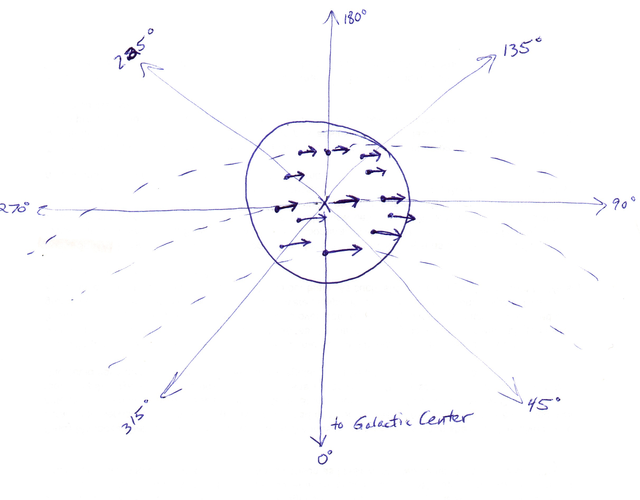

The diagram above shows part of our Galaxy (outlined by the circle), the LSR (marked with an x), and several other nearby Galactic bodies at various Galactic longitudes. The vectors represent these objects’ instantaneous velocities (assuming circular orbits around the Galactic center). (Note that objects closer to the Galactic center are moving faster.) For each Galactic body shown, find the velocity vector of that body relative to the LSR and draw it in the appropriate place on the diagram below.

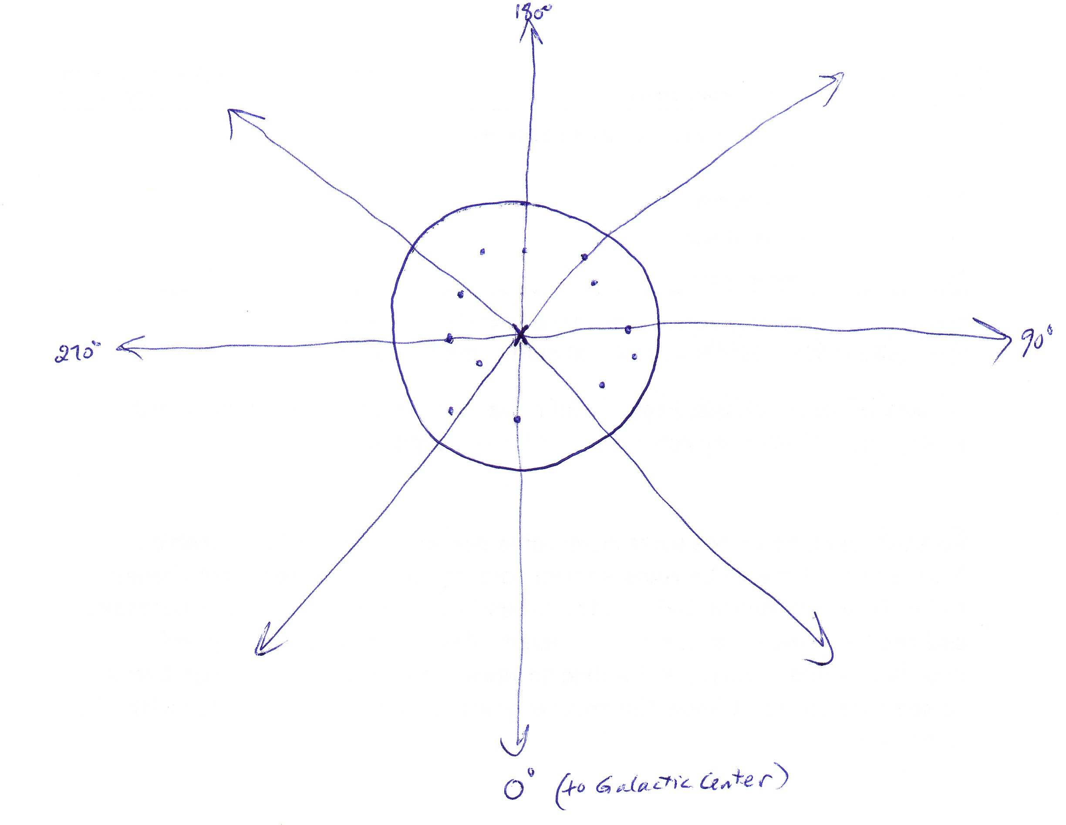

For each velocity vector you found above, resolve the vector into components along and across the line of sight to the LSR. (You can do this directly on the diagram above.)

For each velocity vector, measure the length (in mm) of the component ALONG the line of sight to the LSR and use the obtained values to fill in the table below.

 | Galactic Longitude | Length of component ALONG the line of sight (corresponds to speed toward or away from the LSR)
1
2
3
4
5
6
7
8
9
10
11
12
4. Plot the values in your table on the graph below.

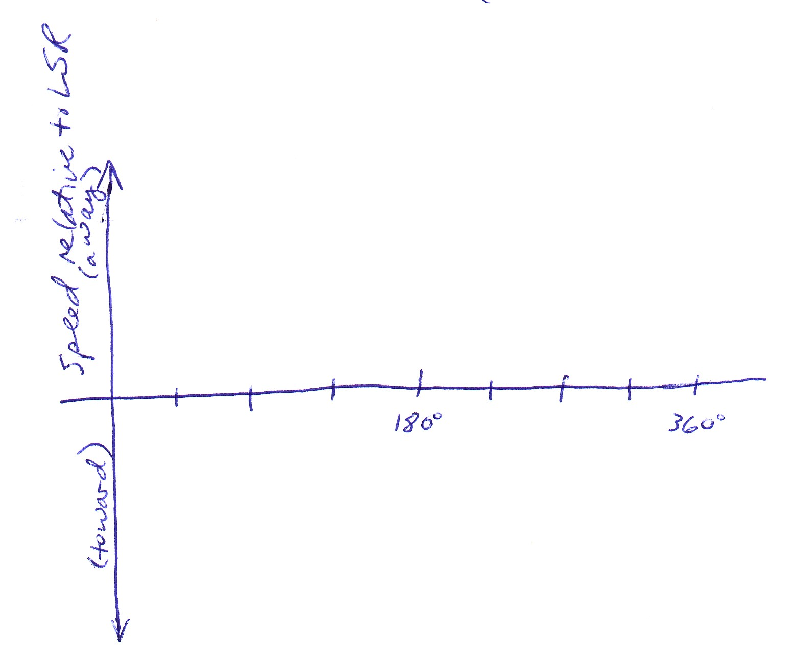
5. What kind of graph did you get? (What is the basic shape?) (Sine curve) Can you explain why the graph has this shape (in terms of the way things should move in the Galaxy)? What is the PERIOD of your plotted data? (180 degrees) Why does your graph have this particular period (in terms of the way things should move in the Galaxy)?

Lesson 4: Hydrogen Hi-jinks

Objective: to correlate Doppler shifts in Galactic hydrogen spectra (obtained by radio telescopes) with Galactic motion

1. Review: Each type of atom or molecule, when excited, emits a characteristic spectrum. The visible spectrum for atomic Hydrogen is:


2. Discussion/lecture: The hydrogen emission spectrum consists of more than just visible lines. For example, there is a 21cm (1420.4 MHz) line that is easily seen by a radio telescope. This line is not seen at exactly 1420 MHz for most of the hydrogen we detect with our radio telescopes. What could cause the line to have a different frequency than expected? (Doppler shift due to motion toward or away from us.)

The diagram below shows what was detected by a radio telescope looking out at a Galactic longitude of 240 degrees and Galactic latitude of 0 degrees. (In other words, the telescope, mounted on Earth, was pointed along the Galactic plane at an angle 240 degrees away from the direction of the Galactic center.)

Is there any hydrogen present along the telescope’s line of sight? (Yes…the telescope detected a strong radio signal in about the right frequency range.) How is this hydrogen moving relative to us (as we ride along with the LSR)? How do you know? (There is a component of this hydrogen’s motion that is AWAY from us along our line sight, because the peak of the signal occurs at a lower frequency than it should. We don’t know anything about this hydrogen’s motion ACROSS our line of sight, however.)

If you know the frequency of greatest signal strength (the peak in the graph above), you can calculate a relative speed (along the line of sight) for the gas. If you point your telescope at as many different directions along the Galactic plane as possible, determine the frequency of greatest signal strength at each Galactic longitude, and use that frequency to calculate the hydrogen’s velocity (along the line of sight) at each Galactic longitude, you will get something like the results shown in the graph below:

Many of the data points are near the curve that shows the ideal expected value. (Think back to Lesson Three to recall why this curve represents the expected behavior.) What could cause some of the points to differ from our expectations? (Not every little bit of material in the Galaxy is moving in perfect circular orbit around the center of the Galaxy!) What can we say about our Galaxy’s dynamic structure after looking at the graph? (Spiral arms of material, all rotating in the same direction around the Galactic center, are certainly a reasonable option for the structure of our Galaxy, but there’s other stuff going on too.)

