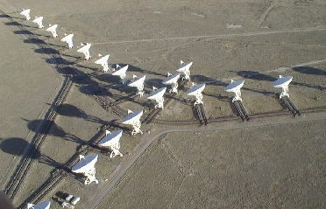
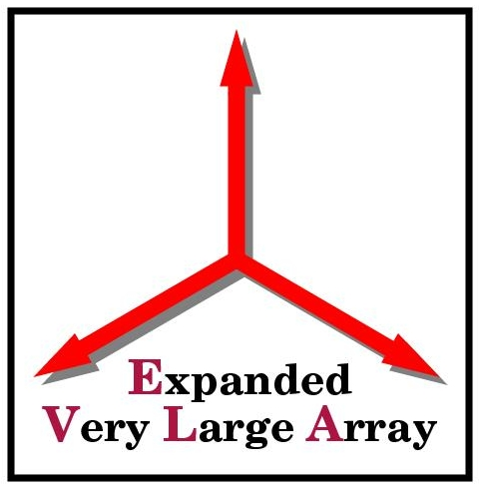
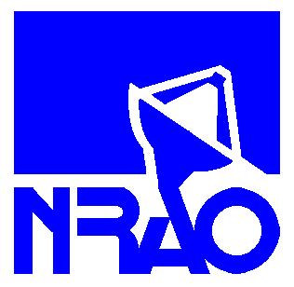
National Radio Astronomy
Observatory
PO Box O

Socorro, NM 87801

Title: Fire Extinguisher Inspection
Document: SEDSP-02
Date: 2026-07-28
Type: Safety Procedure Revision: Initial Release
Authors: Terry Cotter

Safety Procedure

Fire Extinguisher Inspection

Socorro Electronics Division

Keywords: Fire, Extinguisher, Inspection, Safety, Division Head

Author Signatures: Date:

Division Head: Date:

Safety Office: Date:

Change Record

Revision | Date | Author | Sections Affected | Remarks

TABLE OF CONTENTS

1 Introduction 4

2 Purpose 4

3 Responsibilities 4

4 Procedure 4

5 Table of Fire Extinguishers 5

1 Introduction

Fire safety is very important to all employees at NRAO. So inspecting and maintaining the fire extinguishers is a key part of fire safety. This procedure is to be used as an aide for keeping the fire extinguishers up to date.

2 Purpose

The NRAO corporate safety manual states that the Division Head is responsible to make sure each fire extinguisher located in his/her division area is properly inspected. Since, New Mexico Tech has the responsibility to inspect the fire extinguishers at the Pete V. Domenici Science Operations Center (PVDSOC) of NRAO, this procedure is used only to verify that New Mexico Tech is properly maintaining and inspecting each fire extinguisher.

3 Responsibilities

3.1 The Electronics Division Head is responsible to insure fire extinguishers are kept up to date. This procedure is to be performed at a minimum of once per year.

3.2 The Electronics Division Head may assign the task of fire extinguisher verification to any employee within his/her division.

3.3 All Electronics personnel shall be instructed in the safety significance of keeping fire extinguishers up to date.

4 Procedures

Using Table 1, locate each fire extinguisher and perform the following tasks

4.1 Check certification tag and enter inspection date due.
4.2 Check to make sure fire extinguisher is properly secured if required.
4.3 Check to make sure fire extinguisher is in a visible location.
4.4 Enter type of fire extinguisher in table.
4.5 Highlight any fire extinguishers that are deficient.
4.6 Give report to Division Head.
4.7 Division Head reviews report and forwards it to the NM Safety Office.

5 Table of Fire Extinguishers

Note: currently there are 13 fire extinguishers within the electronic’s division area. Eleven of these are on the first floor, one is in the DTS area on the second floor and one is in the Correlator Lab also on the second floor.

Date of Inspection_____________________ Person Inspecting_____________________

# | Location | Type | Date Due | Notes
1 | 1st floor near elevator
2 | 1st floor in maser lab next to hood rooms
3 | 1st floor in maser lab north hood room |  |  | on floor
4 | 1st floor in maser lab south hood room |  |  | on floor
5 | 1st floor in maser lab south hood room in box |  |  | This extinguisher is owned by NRAO and is used on maser trips and is not part of NMT certification
6 | 1st floor near hood
7 | 1st floor in middle of north-south hallway
8 | 1st floor hallway near kitchenette
9 | 1st floor ALMA area next to transformer room
10 | Mechanical room next to front exit
11 | Mechanical room next to back exit
12 | 2nd floor in Correlator Lab |  |  | on floor
13 | 2nd floor in DTS area

