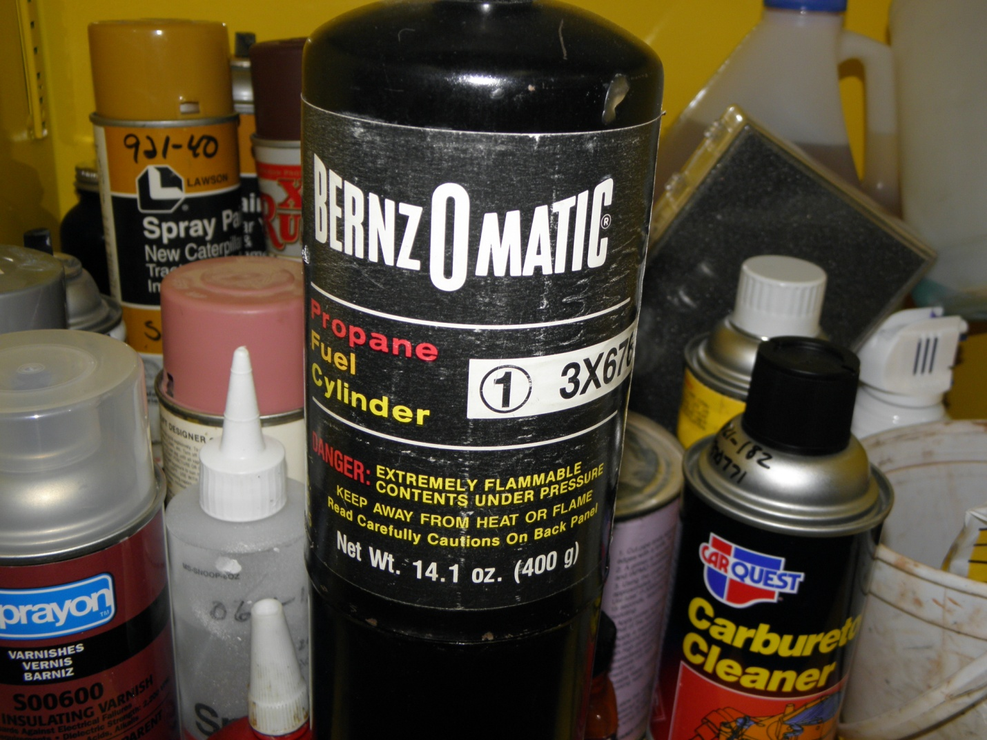

Chemical Name: Propane Fuel Cylinder
Manufacturer: BernzOMatic
Container Sizes: 14.1 oz.
Location: VLA
Disposal: Place empty container in trash. Give partial or full container to safety officer.

